**Restaurant Site**

**Synopsis**

**Submitted by**

**Kush Mittal (181500342)**

**Kartik Agrawal (181500310)**

***In partial fulfillment of the***

***Requirements***

***For the degree of***

***Bachelor of technology***

***In***

***Computer science***



**Supervised By**

**Dr. Manoj Varshney**

**Department of Training and Development**

**GLA University Mathura**

1. **Name / Title of the project:**

Restaurant Site

1. **The problem statement:**

* Some of the Customers at New Restaurants can't be able to keep track of taste of Food dishes.

So, we are making this restaurant site where people can give ratings/reviews to the food dishes

& choose the best dishes of that restaurant.

* Some of the Customers wanted to see actual pictures of the food item before they will order that

food.

* For making online presence of a Restaurant.

1. **Reason for selecting the topic:**

* Difficulty in choosing food item at New Restaurant.
* Difficulty in seeing actual pictures of food items.
* For making online presence of a Restaurant.

1. **Objectives of the project:**

In this project, we are going to make a website where Restaurant owners can log in to our site

through their respective mobile numbers or email id and can manage their database of food

items that they are offering.

Also, they can add their other details such as offers, timings, location.

1. **Literature Survey / Feasibility Study:**

Yes, this project is feasible by the help of Web Development & Database Management System.

1. **Future Scope:**

In the future, we can expand this website for general store owners as well by which they can

manage their products database and along with that they can also generate a bill.

1. **Methodology:**

* Firstly, we will make a log-in page for the user/Restaurant Owner, the user can sign-up on

our website through his mobile number or email I’d & then log-in after completing the

sign-up process.

* After log-in into his account, he can get the option of adding food items details into stock

including details like menu, food items image, food items price, address, timings etc.

* Any Person can also login onto the website & add ratings/reviews, images of a particular

food item.

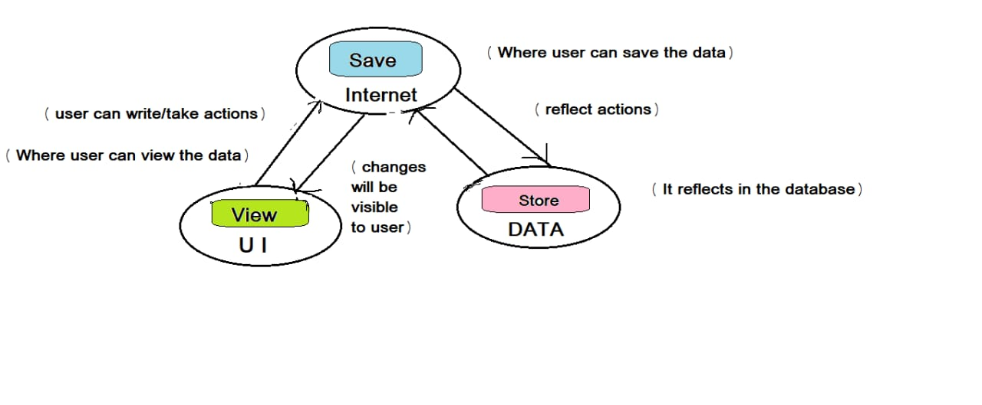

1. **Requirements:**

***Hardware:-***

* Processor: i3 or above
* RAM: 4 GB or above
* Disc space: 20 GB (3 GB for database files + enough GB for shared documents, individual)
* Network card required

***Software:-***

* Git package
* Visual Studio Code as IDE
* OPERATING SYSTEM: Windows 7 or higher
* DATABASE: MySQL or MongoDB
* FRONT-END: HTML, CSS, JAVASCRIPT, BOOTSTRAP4
* BACK-END: Java or C++ or Python

1. **Testing technologies to be used:**

* Functionality Testing
* Usability testing
* Database Testing
* Compatibility testing
* Performance Testing
* Security testing
* Crowd Testing

1. **What contribution would the project make and where?**

It will help Restaurant owners to make online presence of Food items for rating or adding full

Menu so that Customers can order the best rated food items & see timing/location of the

Restaurant.

1. **Scope for extension into a major project:**

Yes, we can expand it into a major project as an application for other Shop Owners site as well.

1. **Conclusion:**

We made a website where Restaurant owners can log in to our site through their respective

mobile numbers or Email I’d and can make their online presence of food items & Menu.

Also, they can add their other details such as offers, timings, location.

1. **References:**

[**https://hackr.io/tutorials/learn-bootstrap**](https://hackr.io/tutorials/learn-bootstrap)

[**https://www.learn-html.org/**](https://www.learn-html.org/)

[**https://bootstrapbay.com/blog/learn-bootstrap/**](https://bootstrapbay.com/blog/learn-bootstrap/)

[**https://www.w3schools.com/html**](https://www.w3schools.com/html)

[**https://www.udemy.com/html-css-bootstrap/**](https://www.udemy.com/html-css-bootstrap/)